
RED CEDAR LAKE POST
VOLUME 47 SPRING 2026
FOR ADDITIONAL UPDATES PLEASE CHECK OUR WEBSITE AT www.redcedarlake.org

NOTES FROM OUR PRESIDENT Mike Albert
Dear RCL Members,

Welcome back! I hope everyone is ready for another summer of fun in the sun with friends and families.

After quite a few years of mild winters we paid the price this year. I want to say thank you to Bill Starr for keeping the roads clear and passable and Kevin Vonderkall for staying on top of the roads and getting them resurfaced early in the spring.

We have a few projects we are working on to better serve the community. A new Kayak rack is being erected on Big Beach. This will allow for everyone that has requested a spot to get one. Please remember that all boats must be removed by November 15th. We are also planning to add sand to Big Beach as well as resurfacing Little Beach. We are also nearing the end of the planning stage for the replacement of the Pillars. Stay tuned for more information. I also want to thank everyone for their contributions to the Beautification Committee. They will be working to add several additional rest areas along Lakeside Drive.

I met with the Postmaster a couple of weeks ago trying to get him to agree to let us put mailboxes in front of our homes. It did not go too well. I explained that we are the only road in town that does not have mailboxes. All he kept saying was he was not going to change the route. This did not seem to be an acceptable argument so I plan to escalate this to the Hartford Postmaster and see if we can at least get a good reason as to why we are being singled out. If we have any members that have a history with the Postal Service I would love the opportunity to speak with you.

We are aware of the Beaver problem we currently have at the lake and we are looking into options to deal with it. Also I would ask everyone to please refrain from feeding the Ducks and Geese. These animals bring many diseases to the Lake and if they are not being fed they will leave the area.

Please note our annual Spring Meeting will be held on Big Beach on Saturday June 13th at 10:00 AM with a rain date of Sunday June 14th at 10:00 AM. Our Annual Fall Membership Meeting will be held on Big Beach on Saturday August 22nd at 10:00 AM with a rain date of Sunday August 23rd at 10:00 AM.
Our Monthly Board Meetings will be held on 5/14, 6/11, 7/9, 8/20 and 9/3. If you wish to attend any of these meetings please let me know at least a week in advance so we can arrange for seating.

As always please remember to slow down on our roads, pick up after your pets and please do not feed the Geese. The gate combination will be changed at the beginning of each month and will be posted in your email. I hope everyone enjoys their Summer and can spend valuable time with family and friends. For anyone that does not have my contact information, I can be reached at 860 817 5698.

Sincerely
Mike Albert
RCLPOA
PAGE TWO

ROADS by Kevin Vonderkall

Welcome back friends and neighbors. As you all can imagine the roads were hit hard with potholes after this harsh winter. I had our contractor come early to fill and roll. This should give more time for the material to settle and help with travel. New material and the finish grading will be done before Memorial Day. Will keep you posted when date is set.

LAKE – John Woodmansee

WATER QUALITY CONTROL

Lake water E. coli levels will be tested at the end of June, July and August. These test results will be made available once they are received.
Pond and Lake Connection Environmental Consultants of North Franklin have submitted the
2026 necessary treatment permit renewal with the Department of Energy and Environmental Protection. Treatment dates will be scheduled in June and again in late summer (if needed). Members will be notified by email and posted signs noting exact treatment dates and any associated water use restrictions.

Marker buoys will be reinstalled in the same locations around the lake to let members know where there are potential underwater hazards.

The dam will continue to be checked periodically. Please let us know if you notice any issues with the dam, marker buoys or water quality.

NEW MEMBERS

We welcome to our Red Cedar Lake Family of Friends and Neighbors.

JILL FRANKE 145 Lakeside Drive

HUGH THORNTON & MAGGIE MATOS 152 Lakeside Drive

BRUCE & PATRICIA COUSINEAU 214 Camp Mooween Rd

PAGE THREE

RED CEDAR LAKE 2026 SUMMER EVENTS

Corn Hole
Friday nights begin May 1st. Warm ups at 6, games at 6:30, $35/per person for the season or $5/night not to exceed $35. Friends and family are welcome.
Fourth of July Boat Parade
Saturday July 4th, rain date Sunday July 5th. Decorate your boat and line up at the end of the lake by the dam @ 5pm. We will start the parade at 5:30 and finish with a flotilla party in the middle after.
Sailboat Races
Sunday mornings begin July 5th. Sailing starts at 11am and will be every Sunday until Labor Day weekend.
BBQ Social/Auction August 1st Big Beach 5PM
Balloon Toss/Ice Cream- July 18th Big Beach 2PM
Painted Rock Hunt Starts July 1st and will go through Labor Day
PIZZA & DJ/Dance Party September 5th Big Beach starts at 5PM
Bingo and Movie Night Big Beach, July 18th, 2026 6:00pm, Movie to follow. Bingo and Movie Night Big Beach, August 22, 2026 6:00pm, Movie to follow.
Sunday Kayaking Begins May 24th thru September 6th
Halloween Hayride October 31st leaves at 5pm. Meet at 92 Reservior Rd
Spring Annual Meeting Big Beach Saturday, June 13, 2026 10:00 am, Rain date Sunday, June 14, 2026
Fall Annual Meeting Big Beach Saturday, August 22, 2026 10:00 am, Rain date Sunday, August 23, 2026

PAGE FIVE

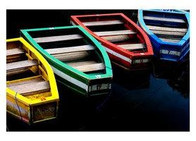 BEACHES

The Porta-Potties will be delivered by Memorial Day.

PLEASE WATCH YOUR EMAIL ,,,
The gate combination will be changed the beginning of each month starting June 1st. The new number each month will be posted on your email.

Here are a few things to remember ………

- No smoking allowed on Big Beach or Little Beach
- CLOSE and LOCK gates when you leave.
- Dogs are NOT allowed on Big Beach and Little Beach.
- NO CHILD under 14 years of age is allowed in the swimming area at either beach without the supervision of an adult 14 years or older.
- SAFE USE OF THE SWIMMING PLATFORM - Excessive rocking and otherwise rough use of the swimming platform at Big Beach can result in its damage. Please take care when using the platform so it remains in good condition for years to come.
- Please bag your garbage and use the garbage cans that have been placed on Big Beach and Little Beach.

OTHER REMINDERS

DRIVE CAREFULLY
Speeding is a concern on our narrow roads. Many children and adults walk and ride bikes on our roads.
PLEASE drive slowly.
The speed limit is 10 mph. Tell your guests, workers and delivery people to drive slowly when coming to your home.

KEEPING THE LAKE AND ROADS CLEAN
Please remember to close trash cans tightly when you leave your property each week. Trash Pickup started Wednesday April 15^{th.} Trash barrels left unsecured are likely to be ransacked by animals, infested with bugs, blown over in a storm or all of the above. Let’s keep our lake properties clean and be good neighbors.

POST YOUR HOUSE NUMBERS CLEARLY SO EMERGENCY VEHICLES CAN EASILY FIND YOUR COTTAGE.

PAGE SIX

BEAUTIFICATION FUND

The RCL Board would like to thank the following members for their donations to the 2026 Beautification Fund. As of May 1, 2026, members have donated $1,220.

Mike & Lynda Albert
Marilyn Alverio
Jim Calkins
David Constantine
Thomas Corto
George & Kerry Curry
Scott & Christine Day
Thomas & Lori Either
Donald & Kathleen Gibson
Lynn Griffin & Joe Dagostino
James Guglielmo
Rich & Linda Haigh
Thomas & Joan Hanson
Paulo & Coleen Henriques
Cathy Hinckley
Jennifer Granger
Nancy Macklin
Frank Miano
Joanne & John Nowosad
Earl & Tracy Ormond
Ray Penrose & Stacey Peirce
Peter & Nora Precourt
Joanne Ropiak
Mark Schultz
John & Roxanne Swidrak
Kevin & Leslie Vonderkall
John & Karen Woodmansee
Hunter Yale

PAGE SEVEN

IN MEMORY



MARJORIE FORTIN

Marjorie Fortin a longtime resident of Red Cedar Lake passed away on March 20, 2026. Marjorie was born in Providence, RI on March 1, 1944. She grew up in Coventry, RI and moved to Connecticut in the late 1960s. Marjorie married her high school sweetheart, and love of her life, Joseph Fortin in June of 1964. They later moved to Lebanon, where they made their home. In her spare time, Marjorie liked to keep busy with various town activities and events. She was a member of the Lebanon Historical Society and Red Cedar Lake Association. She greatly enjoyed taking boat rides with Joe and her beloved dog, Rosie, and getting lost with Joe on the backroads of CT on the search for the state's best hamburger.

We keep Joe and the entire Fortin family in our thoughts and prayers as we remember the many
times we shared with her.

Marjorie's celebration of Life will be held on Sunday, June 28th from 1-5 pm at the St. Joseph's Polish Club 395 South Main St., Colchester.

PAGE EIGHT

SCRRRA HOUSEHOLD HAZARDOUS WASTE

The State of CT annually runs a hazardous waste and paper shredding schedule for each town to drop off various items free of charge.

For Households from the Towns of Bozrah, Colchester, East Lyme, Franklin, Griswold, Groton, Lebanon, Ledyard, Lisbon, Montville, New London, North Stonington, Norwich, Preston, Salem, Sprague, Sterling, Stonington and Waterford only

IF YOU HAVE ANY QUESTIONS CONTACT:
Southeastern Connecticut Regional Resources Recovery Authority at (860) 381-5558)

NOTE: These Events include collection of HHW, mercury and paper shredding

June 13, 2026 Norwich Norwich Public Works 50 Clinton Avenue 9:00 am – 1:00 pm

July 11, 2026 Groton Fitch High School 101 Groton Long Point Road 9:00 am – 1:00pm

August 1, 2026 Montville Tyl Middle School 166 Chesterfield Road, Oakdale (off Route 163) 9:00 am – 1:00 pm

September 19, 2026 North Stonington Across from Wheeler High School 297 Norwich Westerly Road 9:00 am – 1:00 pm

October 3, 2026 Griswold Griswold Public Works (Highway Garage) 1148 Voluntown Road Route 138 (east of Route 395) 9:00 am – 1:00 pm

November 17, 2026 Ledyard Ledyard High School 24 Gallup Hill Road 9:00 am – 1:00 pm

PAGE NINE

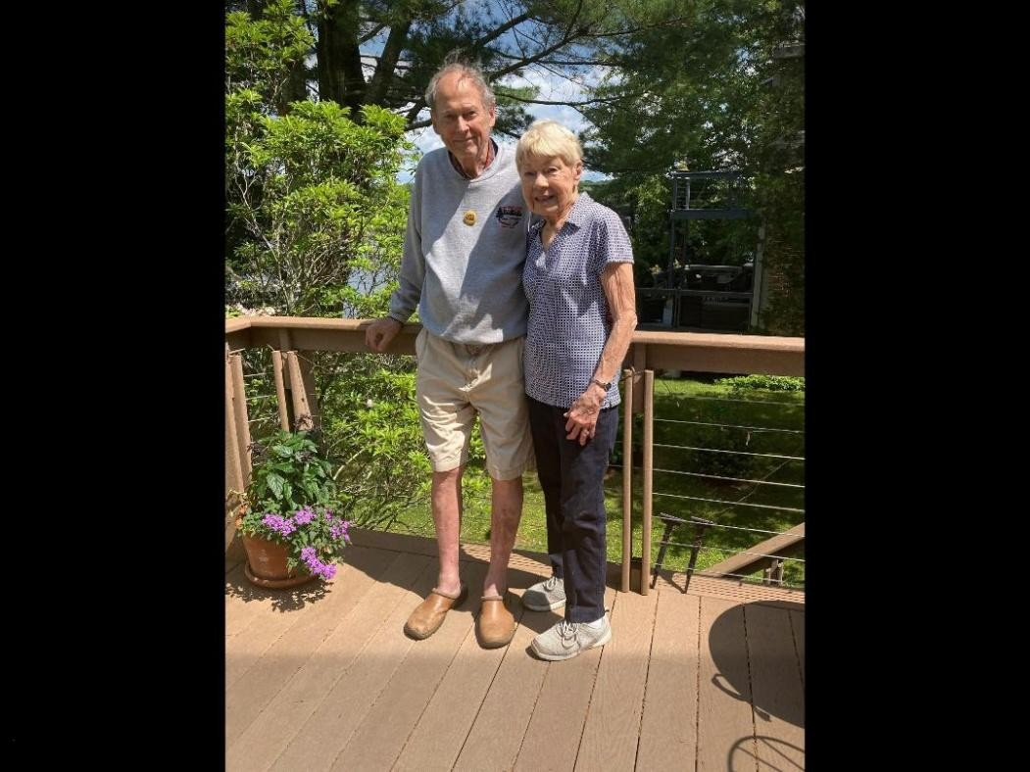

TAKING A MOMENT TO SAY GOODBYE

After many decades as cherished members of the lake association, we find ourselves saying a heartfelt farewell to Larry and Connie Berglund. They leave our lake family in Lebanon to begin an exciting new chapter of their lives in the state of Washington.

Their friendship and kindness have long been a special part of what makes this lake community so meaningful. Through the years, they have touched our lives and created memories that will remain with us for a long time to come.

We wish Larry and Connie safe travels, happiness, good health, and many exciting adventures in the years ahead.

PAGE TEN

RED CEDAR LAKE PROPERTY OWNERS WEBSITE
http://www.redcedarlake.org
Mike Albert | President rclpresident122@gmail.com
Earl Ormond | Vice President earl@ormondromano.com
Stacey Pierce | Secretary jumpersacademy@gmail.com
Linda Rubin | Treasurer Iruby246@gmail.com
Mo Hebb | Chair, Liaison Committee mohebb@charter.net
John Woodmansee | Chair, Water Quality Committee jtwoodmansee@att.net
Kevin Vonderkall | Chair, Roads Committee kvonderkall@yahoo.com
Sandy Boman | Chair, Beaches cboman@sbcglobal.net
Bob Ragaglia | Chair, Newsletter rragaglia@snet.net

Check out the website for any general information, dates of event, current bylaws, annual membership meeting minutes and announcements.
Rules and Regulations are also posted on the website.

~~~~~~~~~~~~~~~~~~~~~~~~~~~~~~~~~~~~~~~~~~~~~~~~~~~~~~~~~~~

RED CEDAR LAKE OFFICERS AND BOARD MEMBERS 2026

