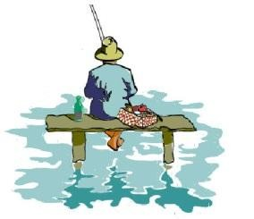
RED CEDAR LAKE POST
VOLUME 46 FALL 2025
FOR ADDITIONAL UPDATES PLEASE CHECK OUR WEBSITE AT www.redcedarlake.org

NOTES FROM OUR PRESIDENT Mike Albert

Dear RCL Members,
Can you believe another summer has passed? As always it was a great time for all. Participation in all activities gets better each year. I want to thank everyone that helped to make this a memorable experience for all.
The Bears, Snakes, Bobcats and Eagles gave us a great reminder of what country life at the lake really is.
Now that the speed bumps are removed please be aware of your speed down our roads. There are still many people walking and playing along Lakeside Drive. Please be careful.
Please note that all kayaks and canoes must be removed from the boat racks no later than November
15th. Leaving boats on the racks during the winter season destroys our boat racks. Any boat stored after
November 15, 2025 will have the locks cut and the boat left on the ground.
I kindly ask all members to please comply
The swim platform at main beach will be removed by end of October. The beautification committee is continuing to work hard on helping beautify our lake.
Please consider adding an additional $25.00 or more to your next year dues to be used for beautification purposes. This is strictly voluntary.
I wish everyone a safe and healthy winter and look forward to seeing you next Spring.
For anyone that does not have my contact information, I can be reached at 860 817 5698.
My mail is rclpresident122@gmail.com
Mike Albert
RCLPOA President PAGE TWO

IN MEMORY


TOM ALI
Tom Ali, a long time member of the Association has passed away. His family was one of the founding families here at Red Cedar Lake.
EUGENE McMULLAN
Eugene McMullan formely of South Windsor, CT. has passed away. Known for his outgoing and friendly nature. He spent many joyful years and cherished his retirement at Red Cedar Lake. He was often seen out on the lake on his Pontoon Boat, or driving around on his golf cart.

TONY LUPINACCI
Tony Lupinacci a long time member of the Assocation has passed away. Tony was a great guy who was loved by all. You could always expect a smile and a very warm welcome every time you interacted with him.

MAY THEY REST IN PEACE
PAGE THREE

ROADS by Kevin Vonderkall

Another season has passed and our roads have held up well. My hope is this will continue through out this winter. I wish everyone a safe and healthy winter and look forward to seeing you in the spring.
Kevin

=====================

LAKE –John Woodmansee
Water Quality Control – The lake water samples were taken and tested at the end of June, July and August. Historically the association has tested for E. coli levels in the water. The Connecticut Department of Heath has estabished E. coli as the indicator organism used for monitoring freshwater swimming water quality. According to the State of Connecticut guidelines for monitoring swimming water, a concentration of E. coli organisms less than or equal to 235 per 100 mi is generally considered satisfactory for a single sample from a swimming area. As results show for the water samples taken on June 30th, July 28th and August 25th RCL is well within the allowable levels.
Once again, I would like to thank Mark Fitton for collecting the sample
Pond and Lake Connection obtained the necessary permits from the Department of Energy and Environmental Protection to treat pondweeds. The first treatment for submersed pondweed was completed on July 14th. After a discussion with Pond and Lake Connection and observations of lake conditions, it was decided to forgo the second treatment, which was meant to target floating leaves. Eliminating this unnecessary treatment provided significant cost savings to the Assocation. Additionally Pond and Lake will conduct an end of the year survey at the beginning of October.

PAGE FOUR
SUMMER FUN ACTIVITIES

This year we had many great activities for our members.

CORNHOLE was back for a fifth season
YOGA on Big Beach with Karen Woodmansee
SAILBOAT RACING started June 30th for another season
BOAT PARADE July 5th for the third season
BALLOON TOSS & ICE CREAM THING EVENT July 12th
SUNDAY KAYAKING every Sunday evening
BINGO and MOVIE NITE was held July 19th & August 23rd
BBQ and AUCTION held August 16th
LAKESIDE TAG SALE & PIZZA PARTY AND DANCE Saturday September 6th

And the 5th annual Halloween hayride is set for the end of October starting at 5PM.
Date to be announced, please watch your email for the date.
The ride will start at 92 Reservoir Rd. The trailer will arrive on the corner of Lakeside and Diane by 5:30-5:45 then go down Lakeside to big beach and back. If you have any questions or want to ride on the trailer please call Jenn Perham 203 915 0999

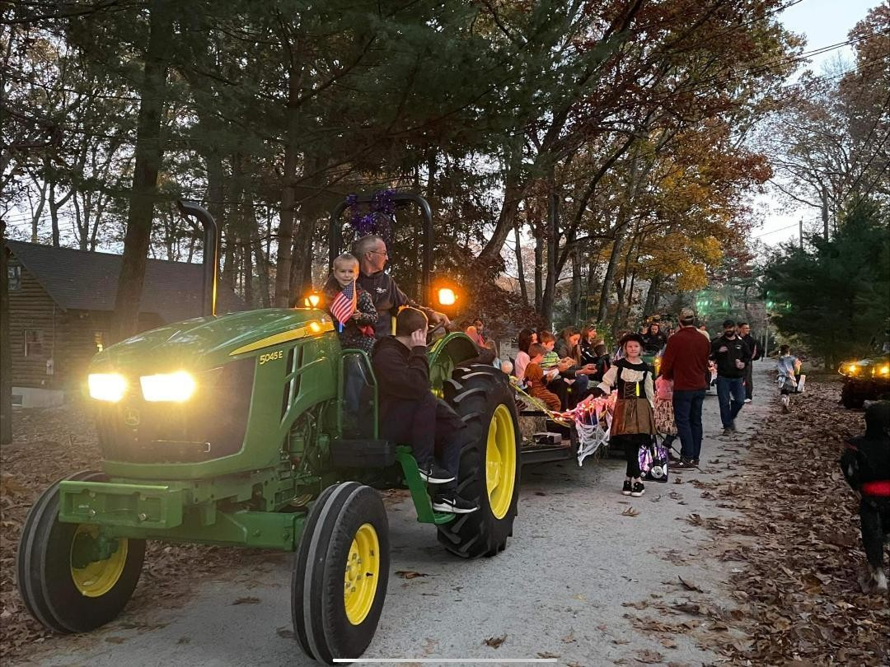
PAGE FIVE

4TH OF JULY BOAT PARADE

What a fabulous way to celebrate the 4th with our own Red Cedar Lake Boat Parade.

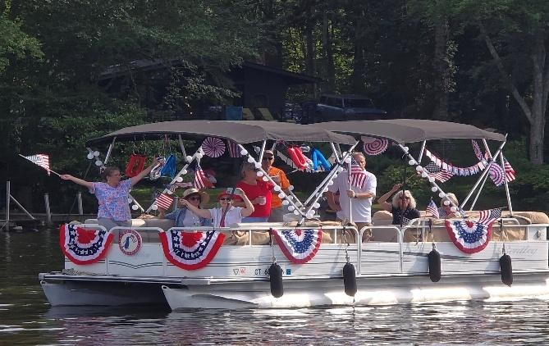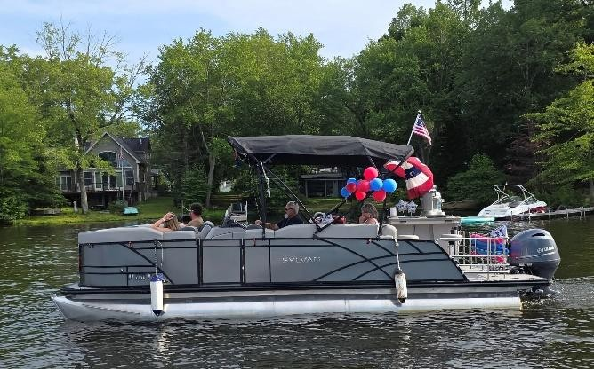

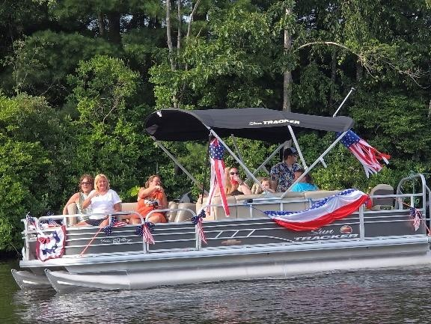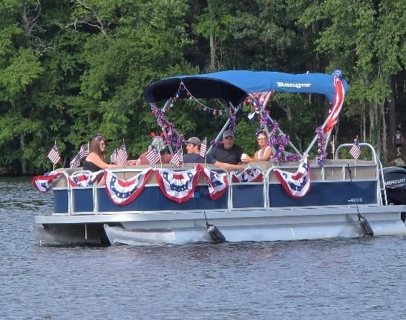
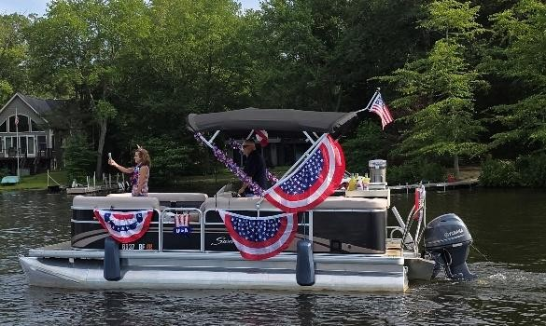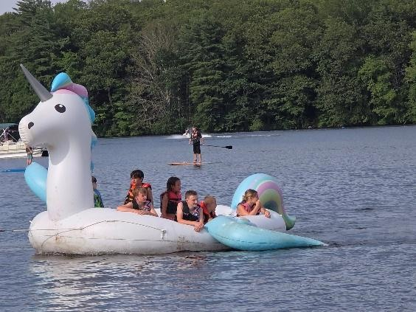
PAGE SIX

BALLOON TOSS & ICE CREAM EVENT

Great fun had by many again this year at Main Beach.

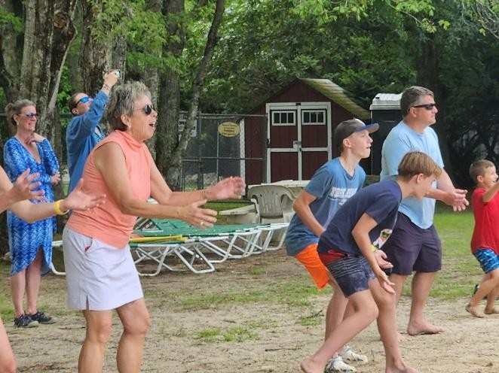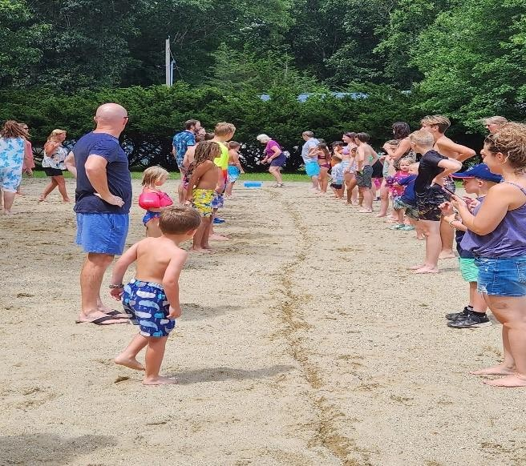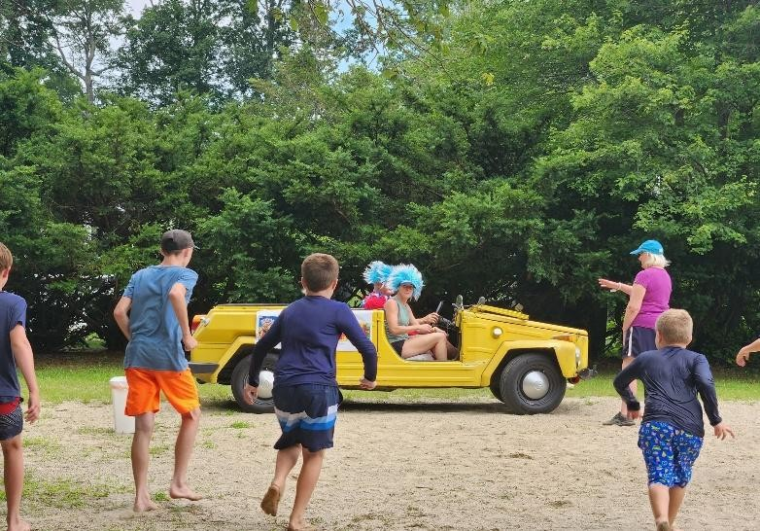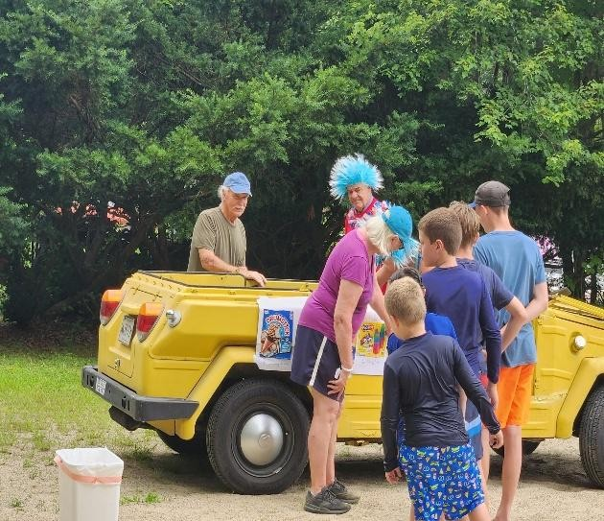

Big thank you to the Wislocki and Jensen families for providing this fun and exciiting activity again this year.

PAGE SEVEN & EIGHT

Thanks to Bob & Honey Ragaglia and Mike & Linda Rubin, Bingo and Movie Nite were again a huge success with great fun and laughter for all.

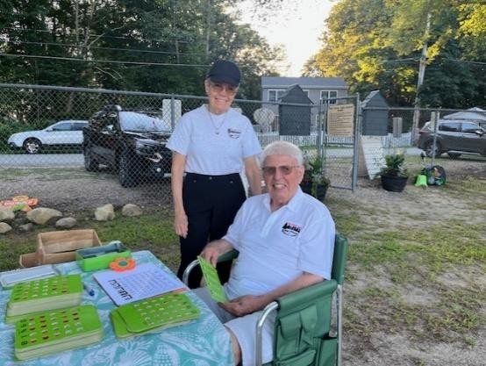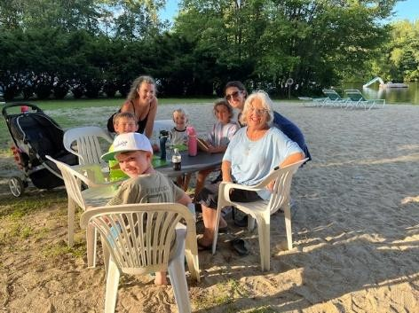

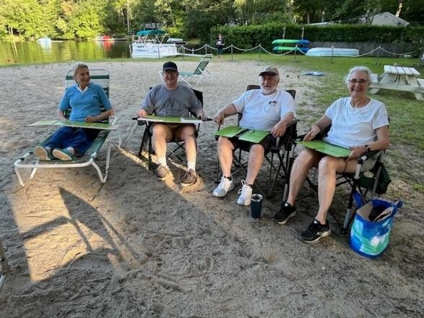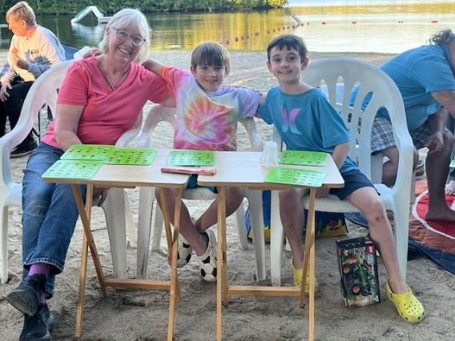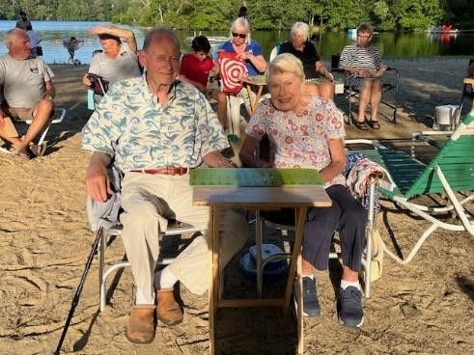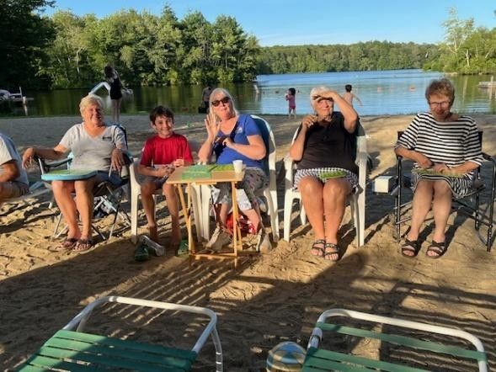
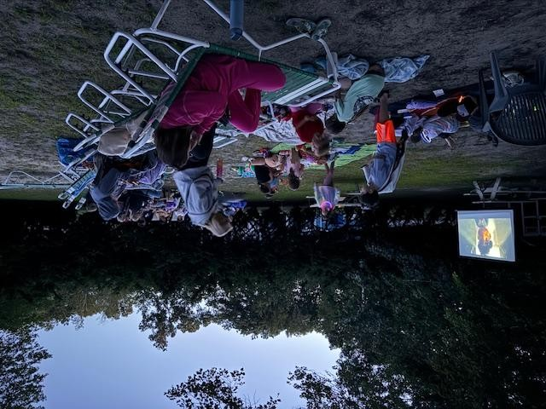
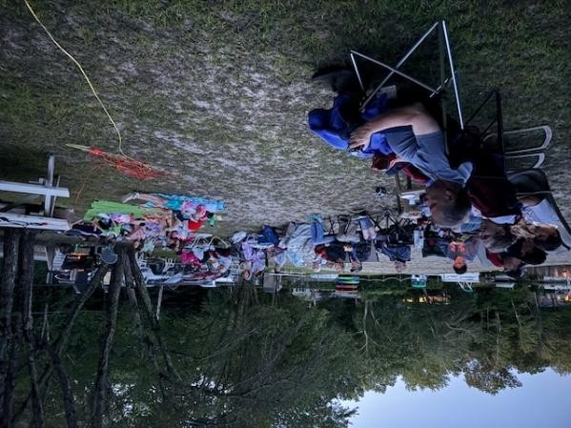
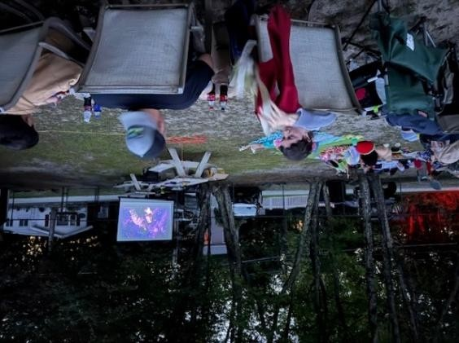
PAGE NINE – TEN - ELEVEN
ANNUAL SOCIAL AND AUCTION
& PIZZA PARTY AND DANCE

A Great big thank you to Brian and Nicole McGrath and all the volunteers who came together to make our annual social event a great success. Lynn Gonzalez for planning the Annual Event and Auction, along with the Pizza Party and Dance. A special thank you to Barbara Starr our auctioneer extraodinaire who was fabulous in every sense of the word.. A thank you to Pat Pelligrino who provided us with the auction audio and the fabulous 50’s and 60’s music for singing and dancing at the Pizza Party, held this year because of rain at Dean Tine’s Pavilion who graciously opened it up for our pizza party and dance.
The auction was a huge huge success with the grand prize” LAKE HOUSE” sign painted and donated by Linda Rubin. Final bidding price at $ 200.00.

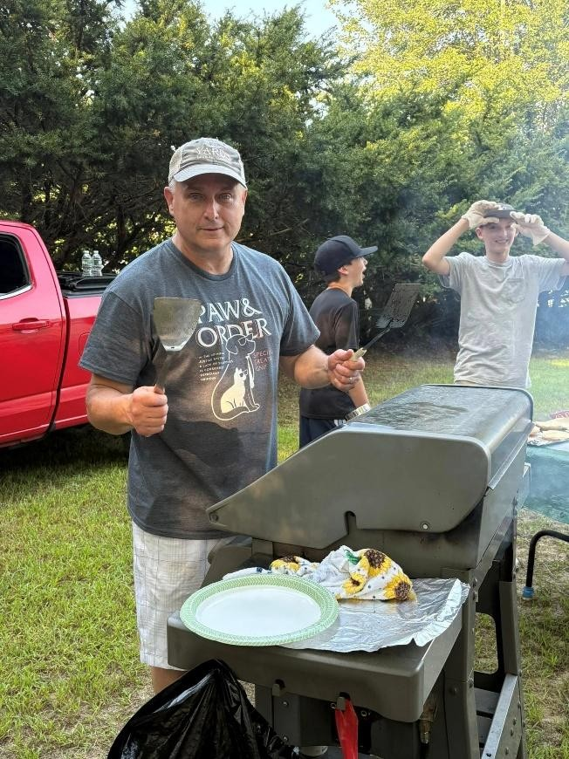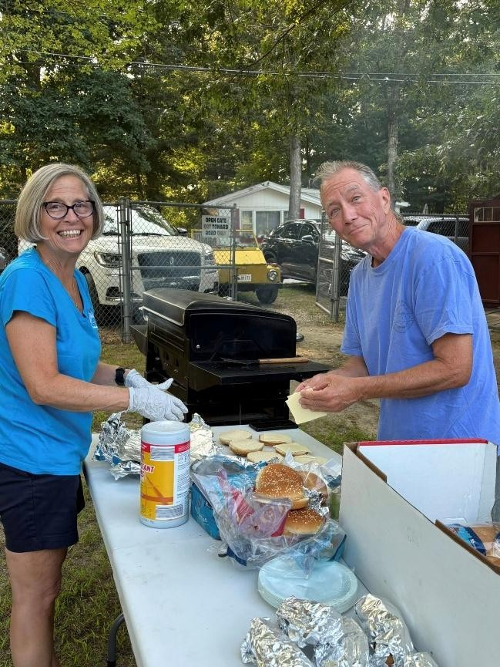

~~~~~~~~~~~~~~~~~~~~~~~~~~~~~~~~~~~~~~~~~~~~~~~~~~~~~~~~~~~~~~~~~~~~~

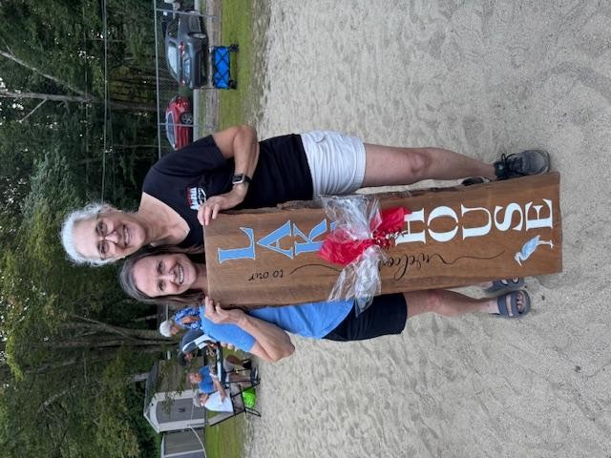
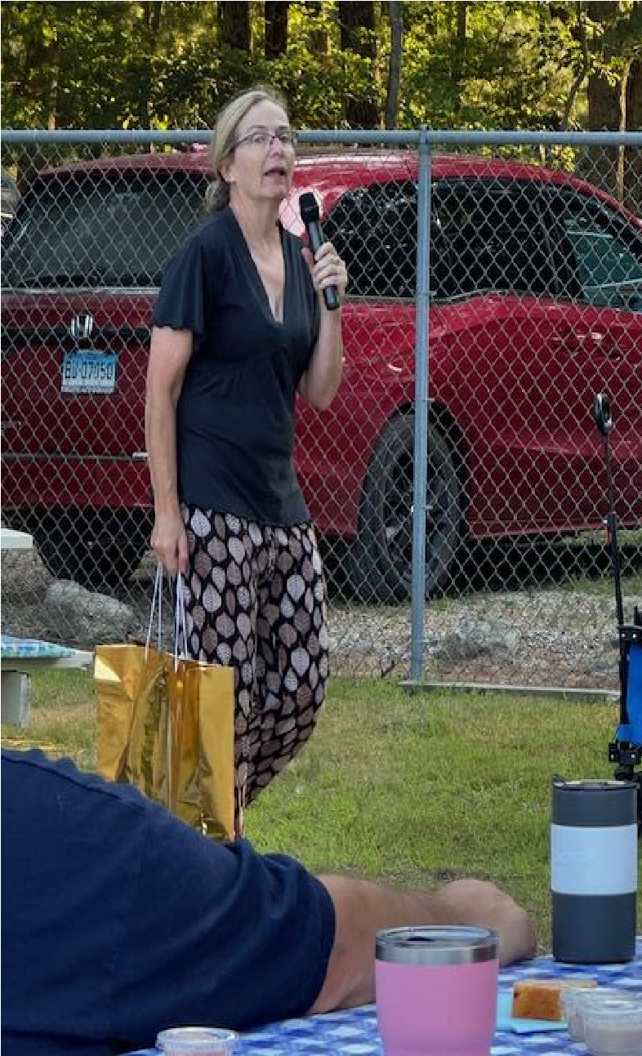
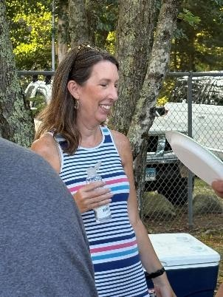

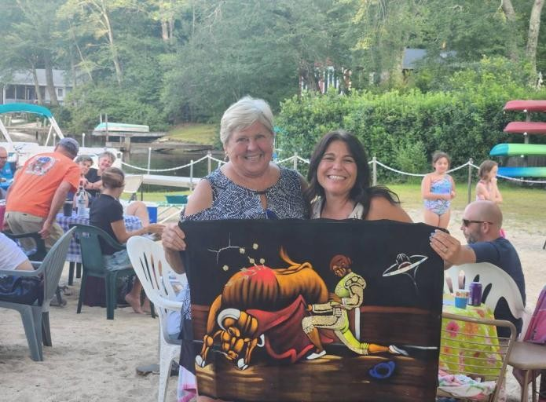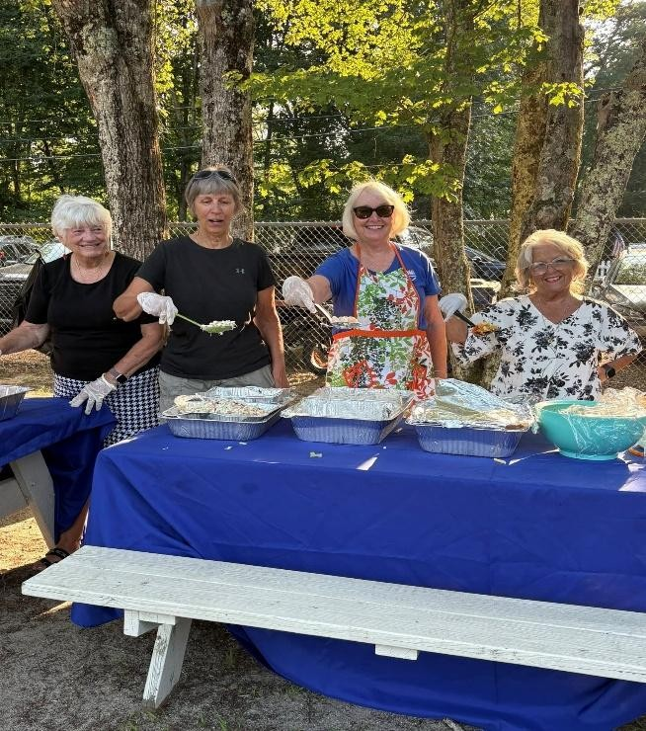
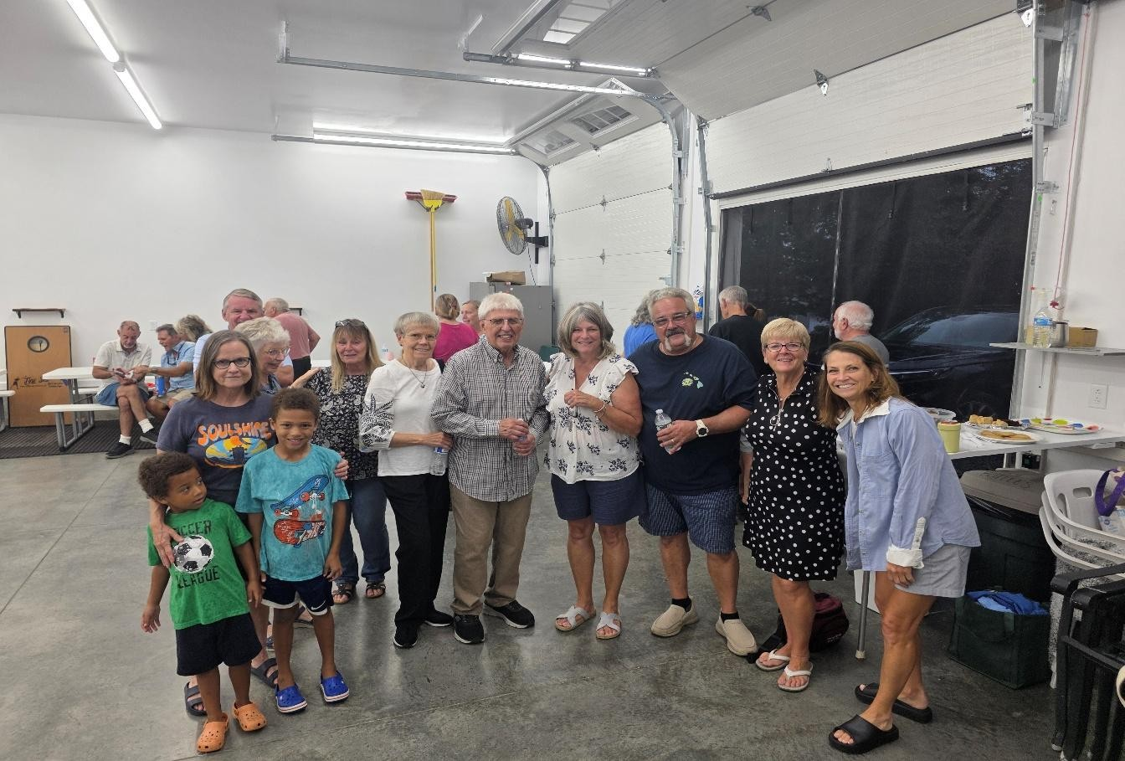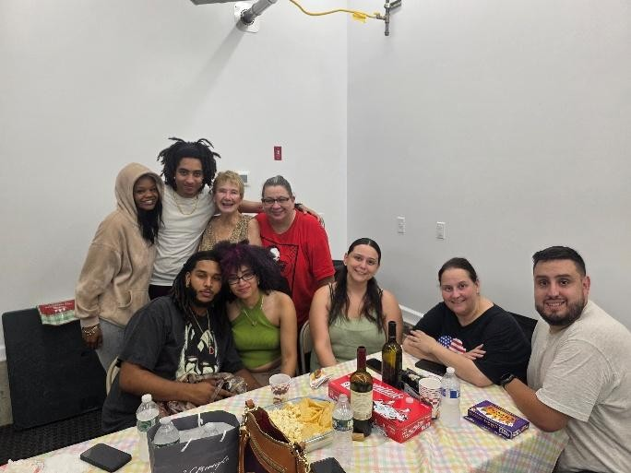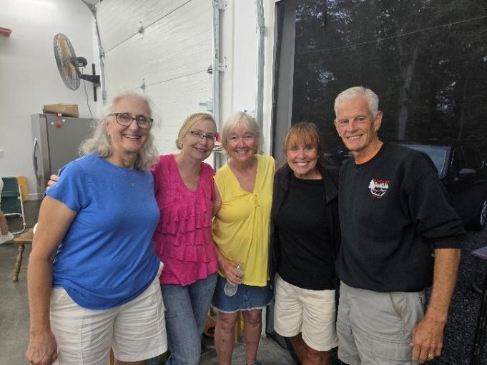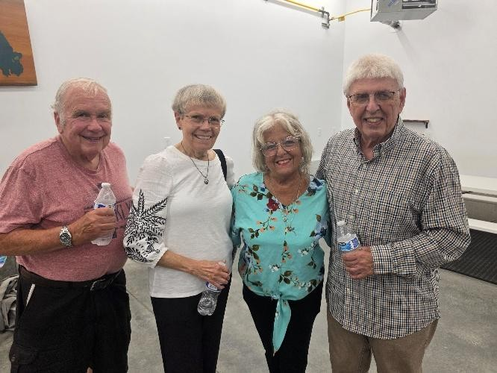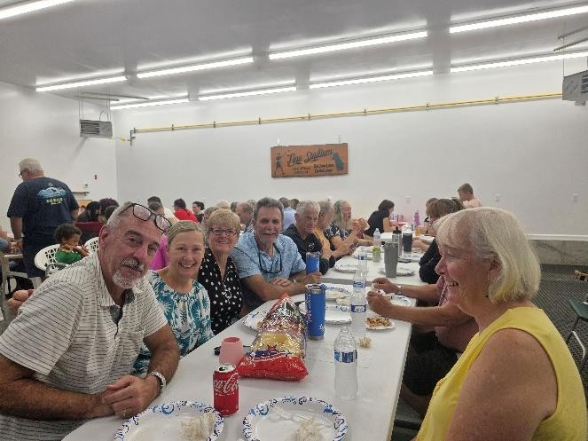

PAGE TWELVE

REMINDERS
DRIVE CAREFULLY

Speeding is a concern on our narrow roads. Many children and adults walk and ride bikes on our roads.
PLEASE drive slowly.
The speed limit is 10 mph. Tell your guests, workers and delivery people to drive slowly when coming to your home.

Mike Albert | President rclpresident122@gmail.com
Earl Ormond | Vice President earl@ormondromano.com
Stacey Pierce | Secretary jumpersacademy@gmail.com
Linda Rubin | Treasurer Iruby246@gmail.com
Mo Hebb | Chair, Liaison Committee mohebb@charter.net
John Woodmansee | Chair, Water Quality Committee jtwoodmansee@att.net
Kevin Vonderkall | Chair, Roads Committee kvonderkall@yahoo.com
Sandy Boman | Chair, Beaches cboman@sbcglobal.net
Bob Ragaglia | Chair, Newsletter rragaglia@snet.net
POST YOUR HOUSE NUMBERS CLEARLY SO EMERGENCY VEHICLES CAN EASILY FIND YOUR COTTAGE

RED CEDAR LAKE PROPERTY OWNERS WEB SITE http://www.redcedarlake.org

Check out the web site for any general information, dates of event, current bylaws, annual membership meeting minutes and announcements.
Rules and Regulations are also posted on the website.

RED CEDAR LAKE OFFICERS AND BOARD MEMBERS 2025-26

